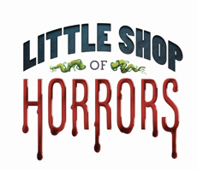
Auditions
July 30 & 31, 2024
6-8:00 pm
Huber Opera House

Production Dates: October 1 1-12-13, 2024
Director: Jennifer Ankney

